Diabetic Retinopathy

* It is the diseases of the retina caused by microangiopathy due to long term effect of diabetes leading to progressive damage of the retina and blindness.
* It is caused by damage to the blood vessels of the light-sensitive tissue at the retina.
* As the sugar level increases in the blood can lead to block of the tiny blood vessels that not supply the blood to retina.
* At first, diabetic retinopathy may cause no symptoms or only mild vision problems.

Symptoms:

You might not have symptoms in the early stages of diabetic retinopathy.

As the condition progresses, diabetic retinopathy symptoms may include:

1. Spots or dark strings floating in your vision
2. Blurred vision’
3. Impaired color vision
4. Vision loss

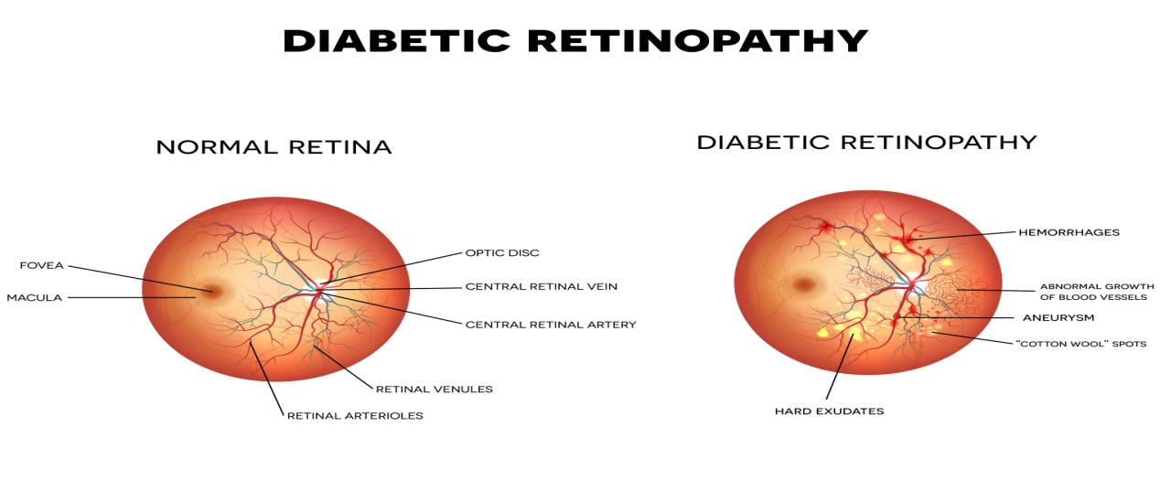

There are four stages of Diabetic Retinopathy

1. Mild
2. Moderate
3. Severe nonproliferative
4. Proliferative

* In the first stage, mild nonproliferative, there will be balloon-like swelling in small areas of the blood vessels in the retina
* In the second stage, moderate nonproliferative retinopathy, some of the blood vessels in the retina will become blocked.
* In the third stage, Severe nonproliferative retinopathy brings with it more blocked vessels, which leads to areas of the retina no longer receiving adequate blood flow.

Without proper flow, the retina can’t grow new blood vessels to replace the damaged ones.

1. In the fourth and final stage is known as proliferative retinopathy. This is the advanced stage of the disease. Additional new blood vessels will begin to grow in the retina, but they will be fragile and abnormal.

Because of this, they can leak blood which will lead to vision loss and possibly blindness.

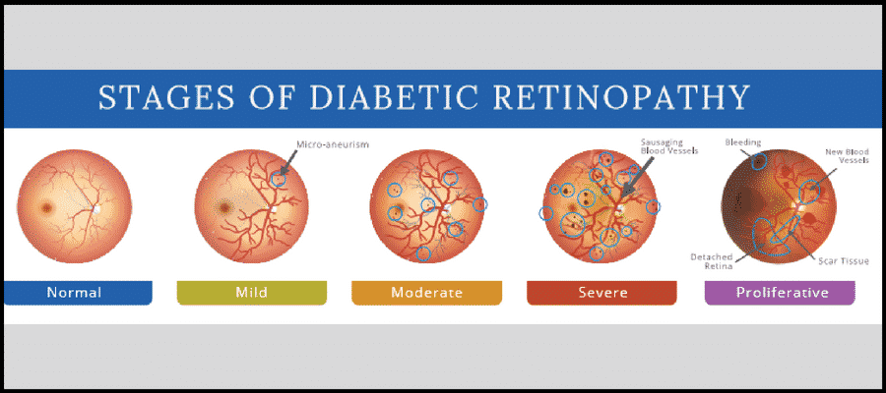

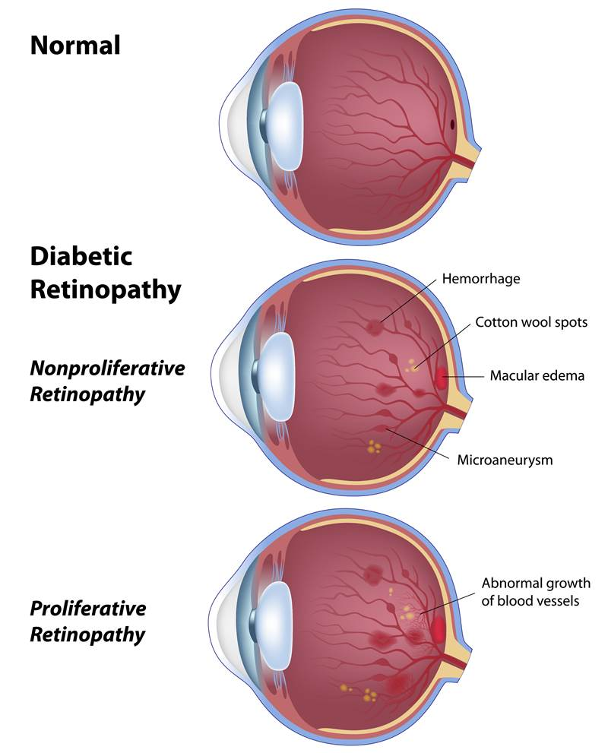

Risk Factors:

Anyone who as has diabetes can develop diabetic retinopathy.

1. Poor control of your blood sugar level
2. High blood pressure(BP)
3. High cholesterol
4. Pregnancy
5. Tobacco use
6. Obesity

Complications:

It leads to serious vision problem

1. Vitreous hemorrhage

The new blood vessels may bleed into the clear, jelly-like substance that fills the centre of the eye.

If the amount of bleeding is small, you might see only a few dark spots. Otherwise it will completely block your vision

Unless your retain is damaged, your vision may return to its previous clarity.

1. Retinal detachment

The abnormal blood vessels associated with diabetic retinopathy stimulate the growth of scar tissue, which can pull the retina away from the back of the eye.

This may cause spots floating in your vision, flashes of light or severe vision loss.

1. Glaucoma

New blood vessels may grow in the front part of your eye and interface with flow of fluid out of the eye, causing pressure in the eye to build up(glaucoma).

This pressure can damage the nerve that carries images from your eye to your brain.

1. Blindness

Eventually, diabetic retinopathy, glaucoma or both can lead to complete vision loss.

Treatment:

LASER treatment:

1. Focal laser

Burns only Microaneurysm.

1. Grid laser

Around the edema except the foveolar avascular zone.

1. Pan retinal photocoagulation

It burns the viable retina which is suffering from ischemia, thus reduces the oxygen demand of retina & prevents hypoxia.

As it burns the ischemic retina, so reduces VEGF secretion by the ischemic retina.

INTRA VITREAL INJECTION:

Anti-VEGF(vascular endothelial growth factor) injection

It’s a humanized monoclonal antibody fragment.

Anti-VEGF binds with VEGF Neutralization of VEGF, so VEGF cant bind to receptor.

Avastin: -- dose -1.25mg

Lucentis: -- dose – 0.5mg

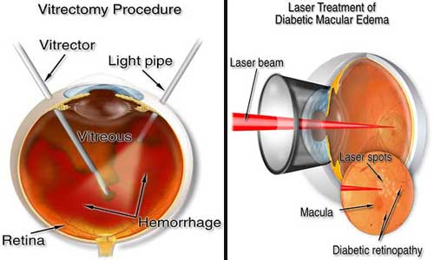

Laboratory test:

1. Blood sugar- FBS, RBS, 2HPPBS
2. Serum lipid profile
3. Medical evaluation of HbA1c
4. Ancillary test
5. Color fundus photograph
6. Fundus Fluorescein angiography
7. OCT

Even after treatment for diabetic retinopathy, you will need regular eye checkup. At some stages, additional treatment may be recommended.

Prevention:

If you have diabetes, reduce your risk of getting diabetic retinopathy by doing the following

1. Manage your diabetes
2. Monitor your blood sugar level
3. Ask your doctor about a glycosylated hemoglobin test
4. Keep your blood pressure and cholesterol under control
5. Don’t smoke or use other types of tobacco
6. Pay attention to vision changes

Departments:

1. Ophthalmologist
2. Low vision specialist